**WRITE UP**

We start with opening cmd promt, connecting to the server using cmd ‘ssh’.

* After connecting to the server we use cmds to access different directories and files to find the password to the next level.
* For the lvls 0-2 I was able to clear them using the commands ‘ls’ and ‘cat’.  
  Here I learned that for reading files with spaces I have to type the name in **“”**And for reading files that start with ‘-‘ I have to use ‘./’ before the name of the file.
* For the lvl 3 I had to change into a new directory which I did with the help of the cms ‘cd’.
* For lvl 4 I tried it initially by reading all files and finding the correct password but it was the wrong approach, then I did it by using the ‘find’ cmd to find out the type of the files that exist and read the correct file.
* For lvl 5 I simply used the ‘file’ cmd.
* For lvl 6 I simply found all the files and read the one file for which the permission was not denied had the pswd.
* For lvl 7 I learnt about the ‘grep’ cmd and used it to find the word millionth and obtained the pswd.
* For lvl 8 I learnt about the cmd ‘sort’ and ‘uniq’ to find out the unique lines in a sorted manner. I used a tag in uniq to see which line occurred only once.
* For lvl 9 I learnt the use of ‘strigns’ cmd to find all printable characters and used grep along with it.
* For lvl 10 I used ‘base64 -d’ to decode the answer.
* I used youtube and google to learn some stuff, like the use of ssh and cmds.
* For lvl 11 I took help and then completed it.
* ~ means the home directory of the logged-on user whereas ~/ means the path to the beginning of a directory.
* I operated on lvl 12 with great difficulty, I watched 2 tutorials on youtube and used ‘bzip2’, ‘gzip -d’, mv, xxd -r, tar -xf to clear this lvl.
* In lvl 13 I got the pswd for lvl14 by using the private key.
* In lvl 14 I simply got the pswd by connecting to a new port and reentering the pswd.
* In lvl 15 after connecting to the port and entering the pswd I got the next pswd
* In lvl 16 after finding the ports and connecting to them one by one of them gave me a rsa key which I copied and saved it and encrypted it and then used it as a key to get to lvl 17
* In lvl 17 I used the cmd “diff” to find the different lines and used both the pswds to check which one is correct
* In lvl 18 I used the cmds along with the ssh line to read the file and get the pswds, I read abt this online
* In lvl 19 I switched to bandit20-do and read the file. I did not understand the concept of it as I did it by watching it online

Level 00

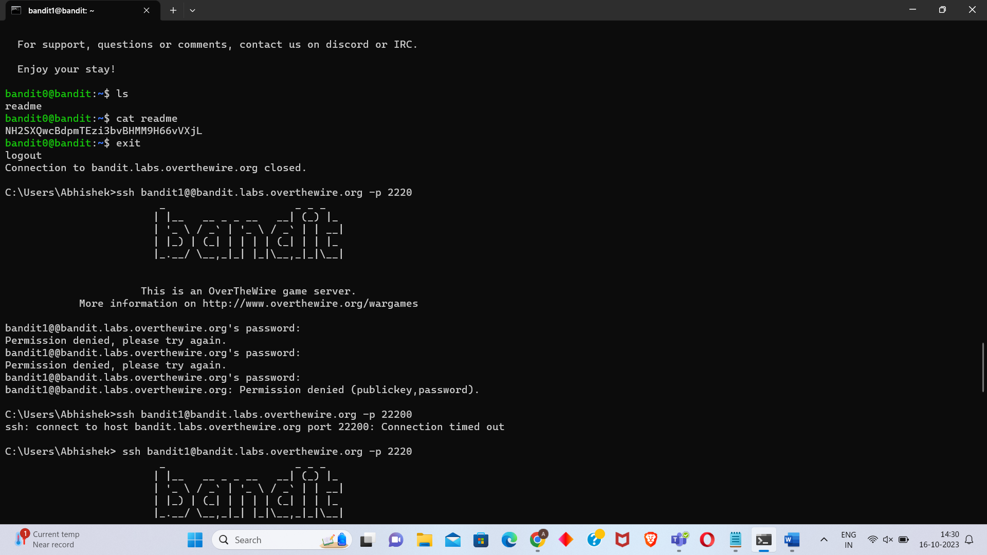

Level 01

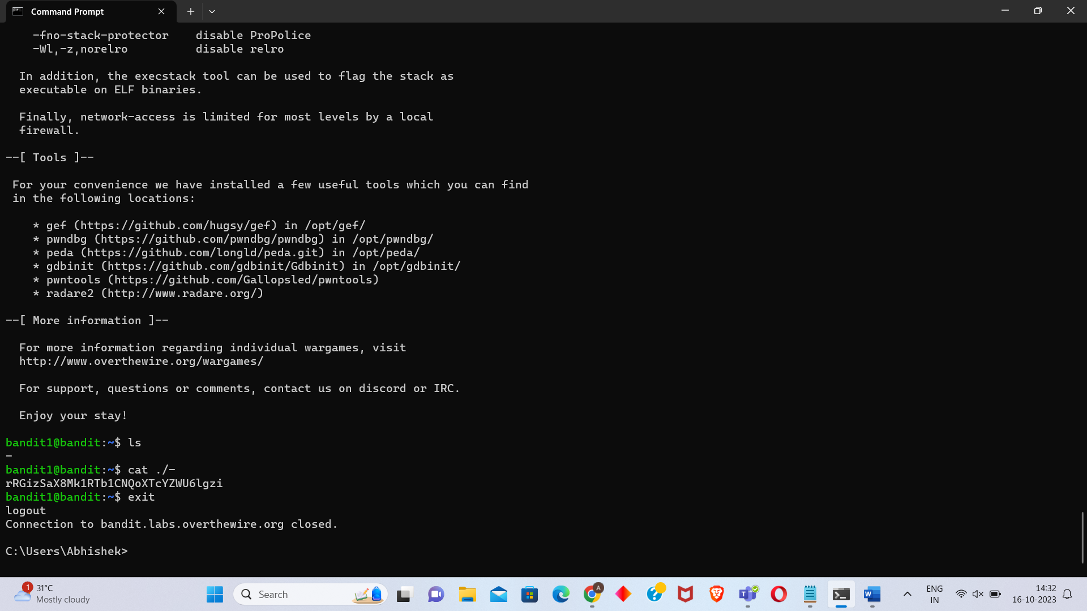

Level 02

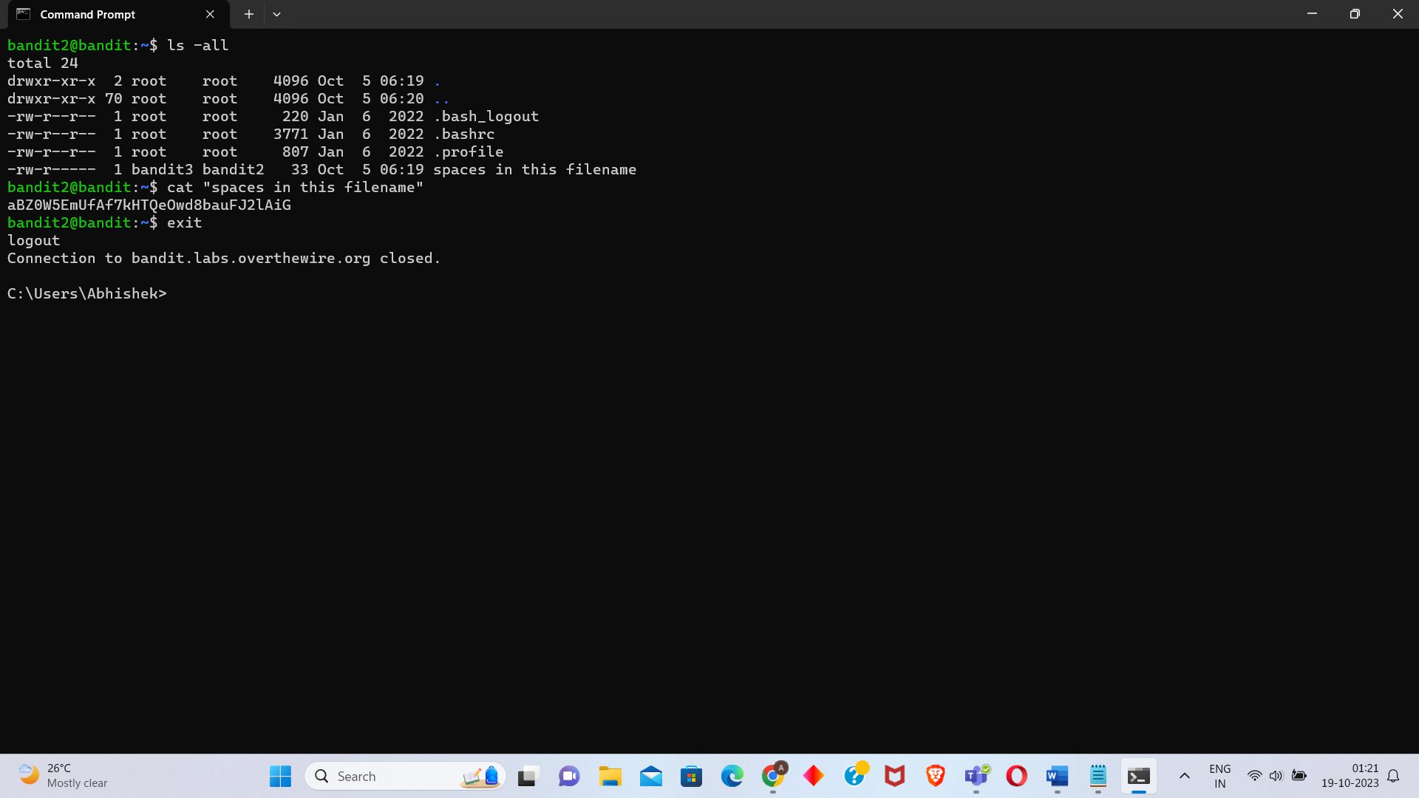

Level 03

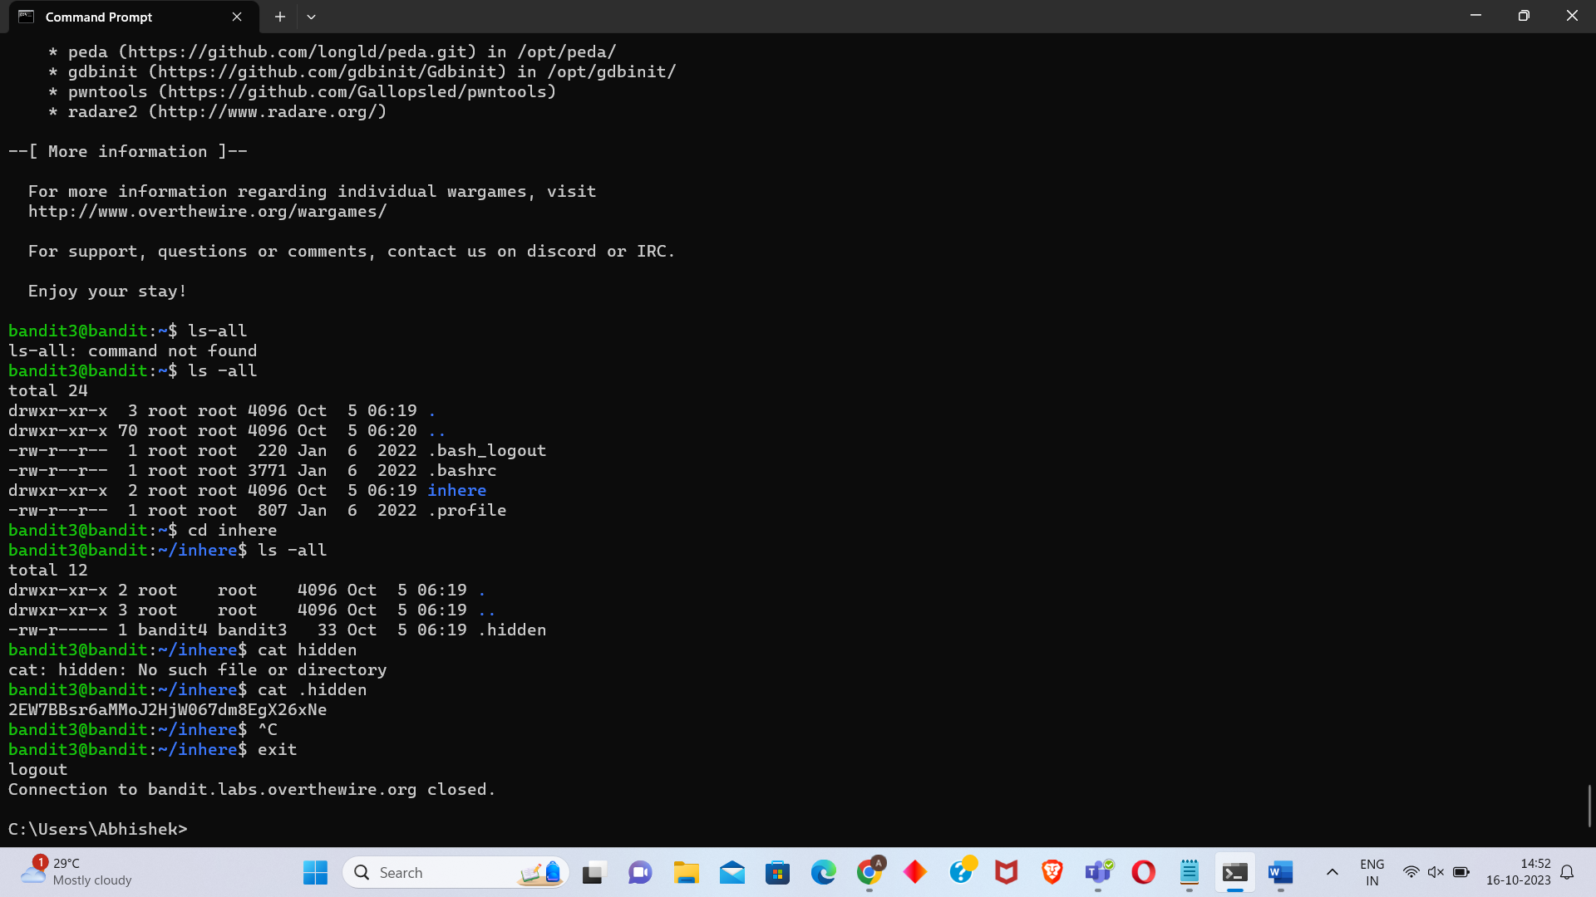

Level 04

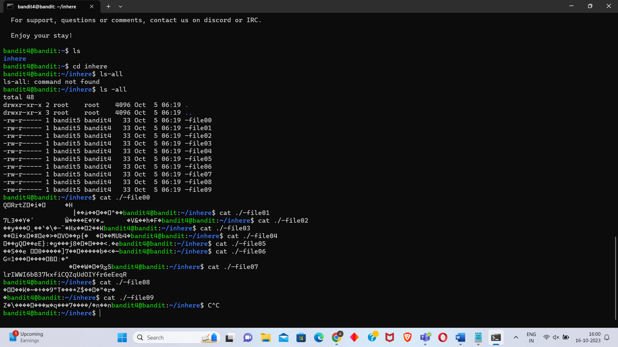

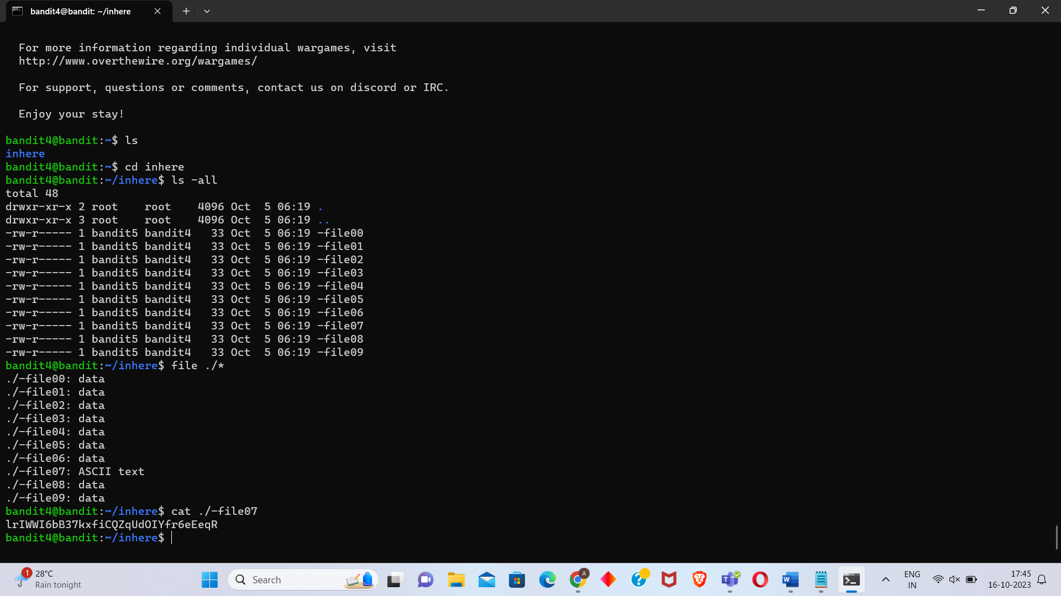

Level 05

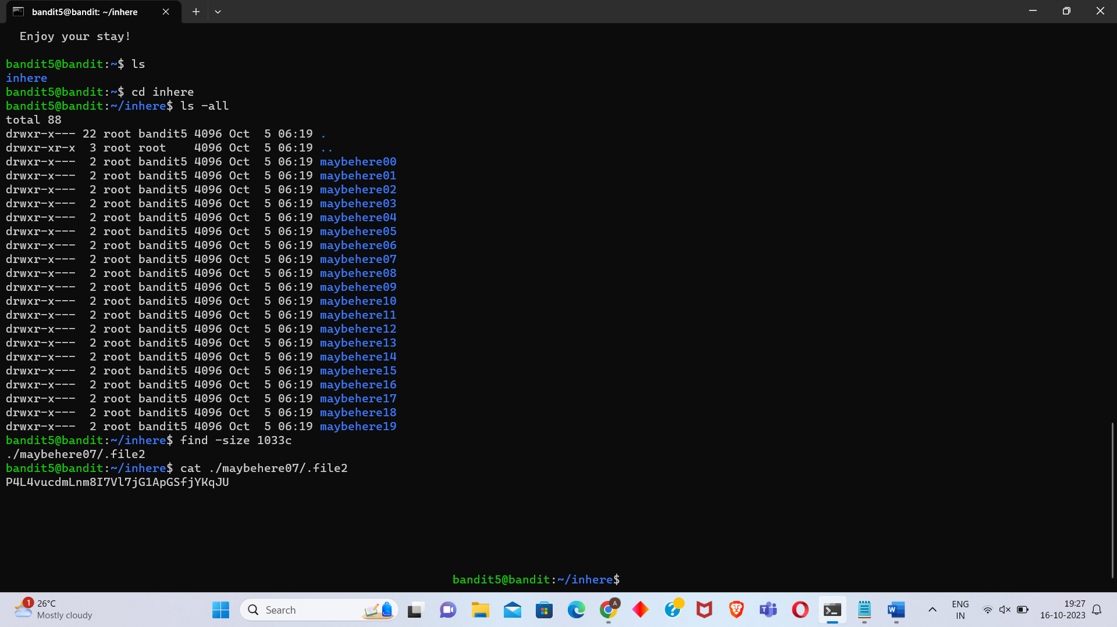

Level 06

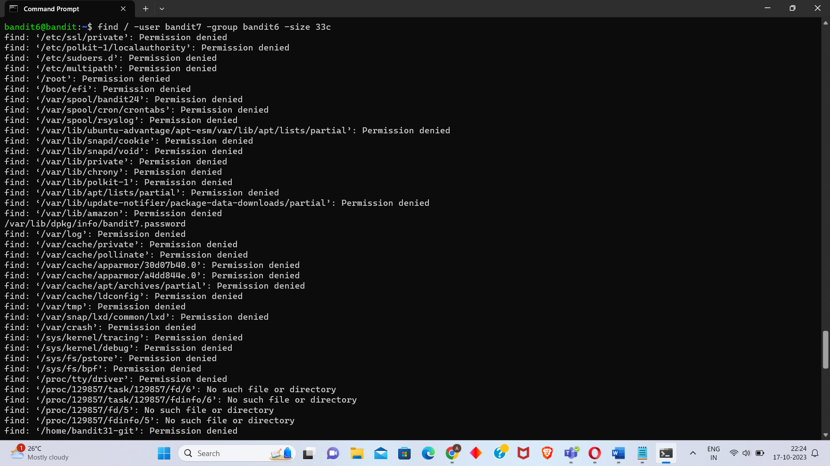

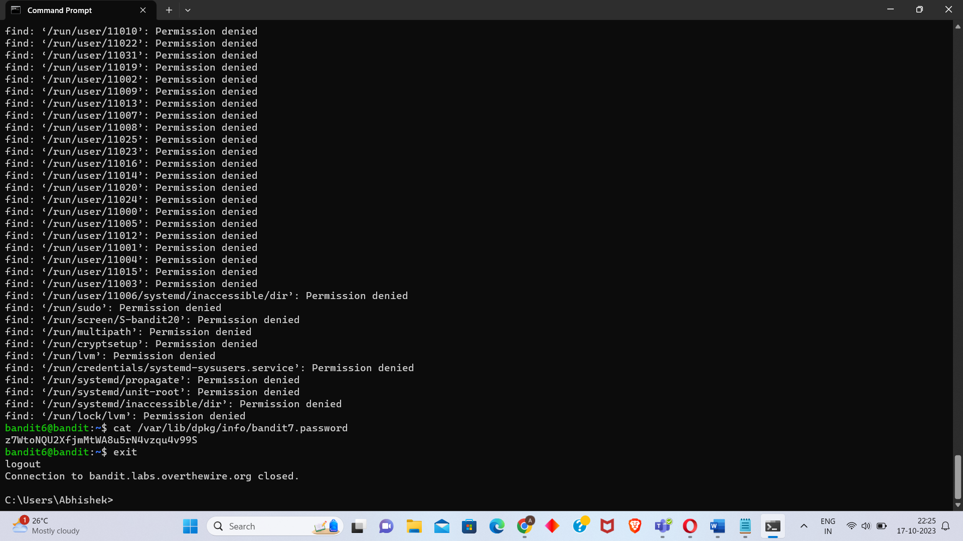

Level 07

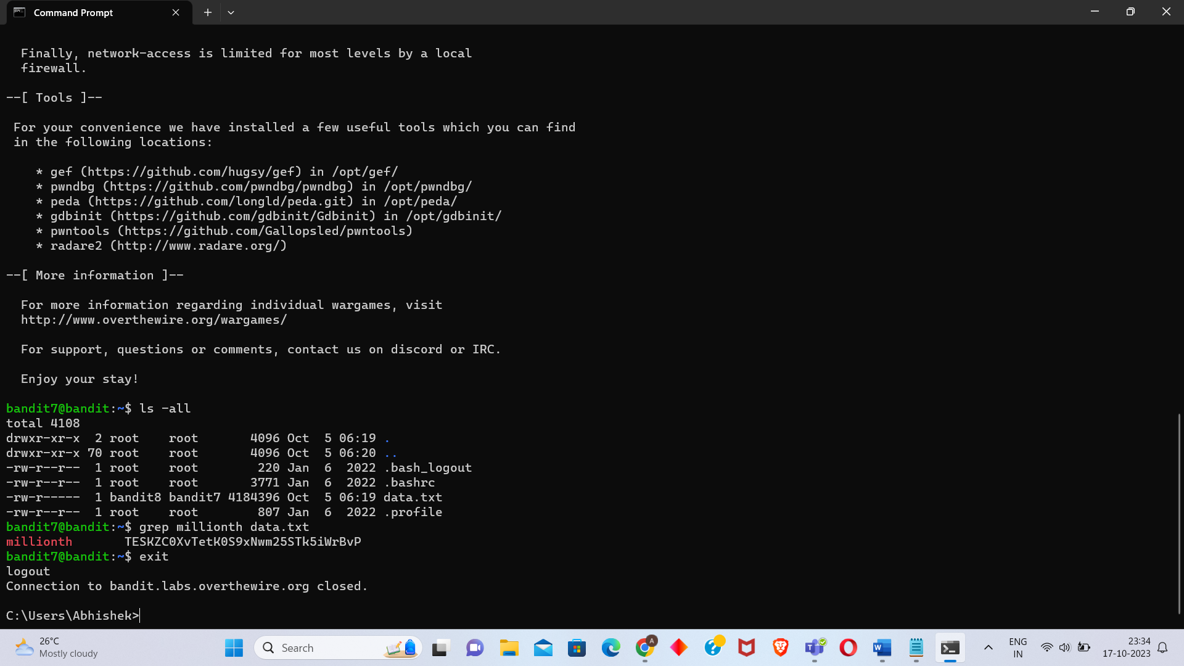

Level 08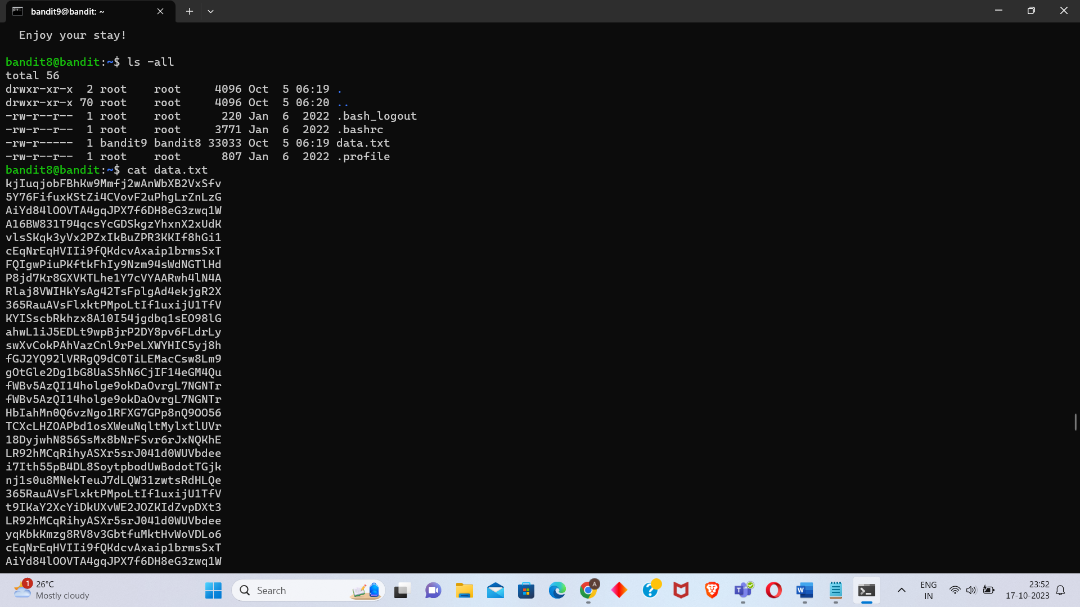

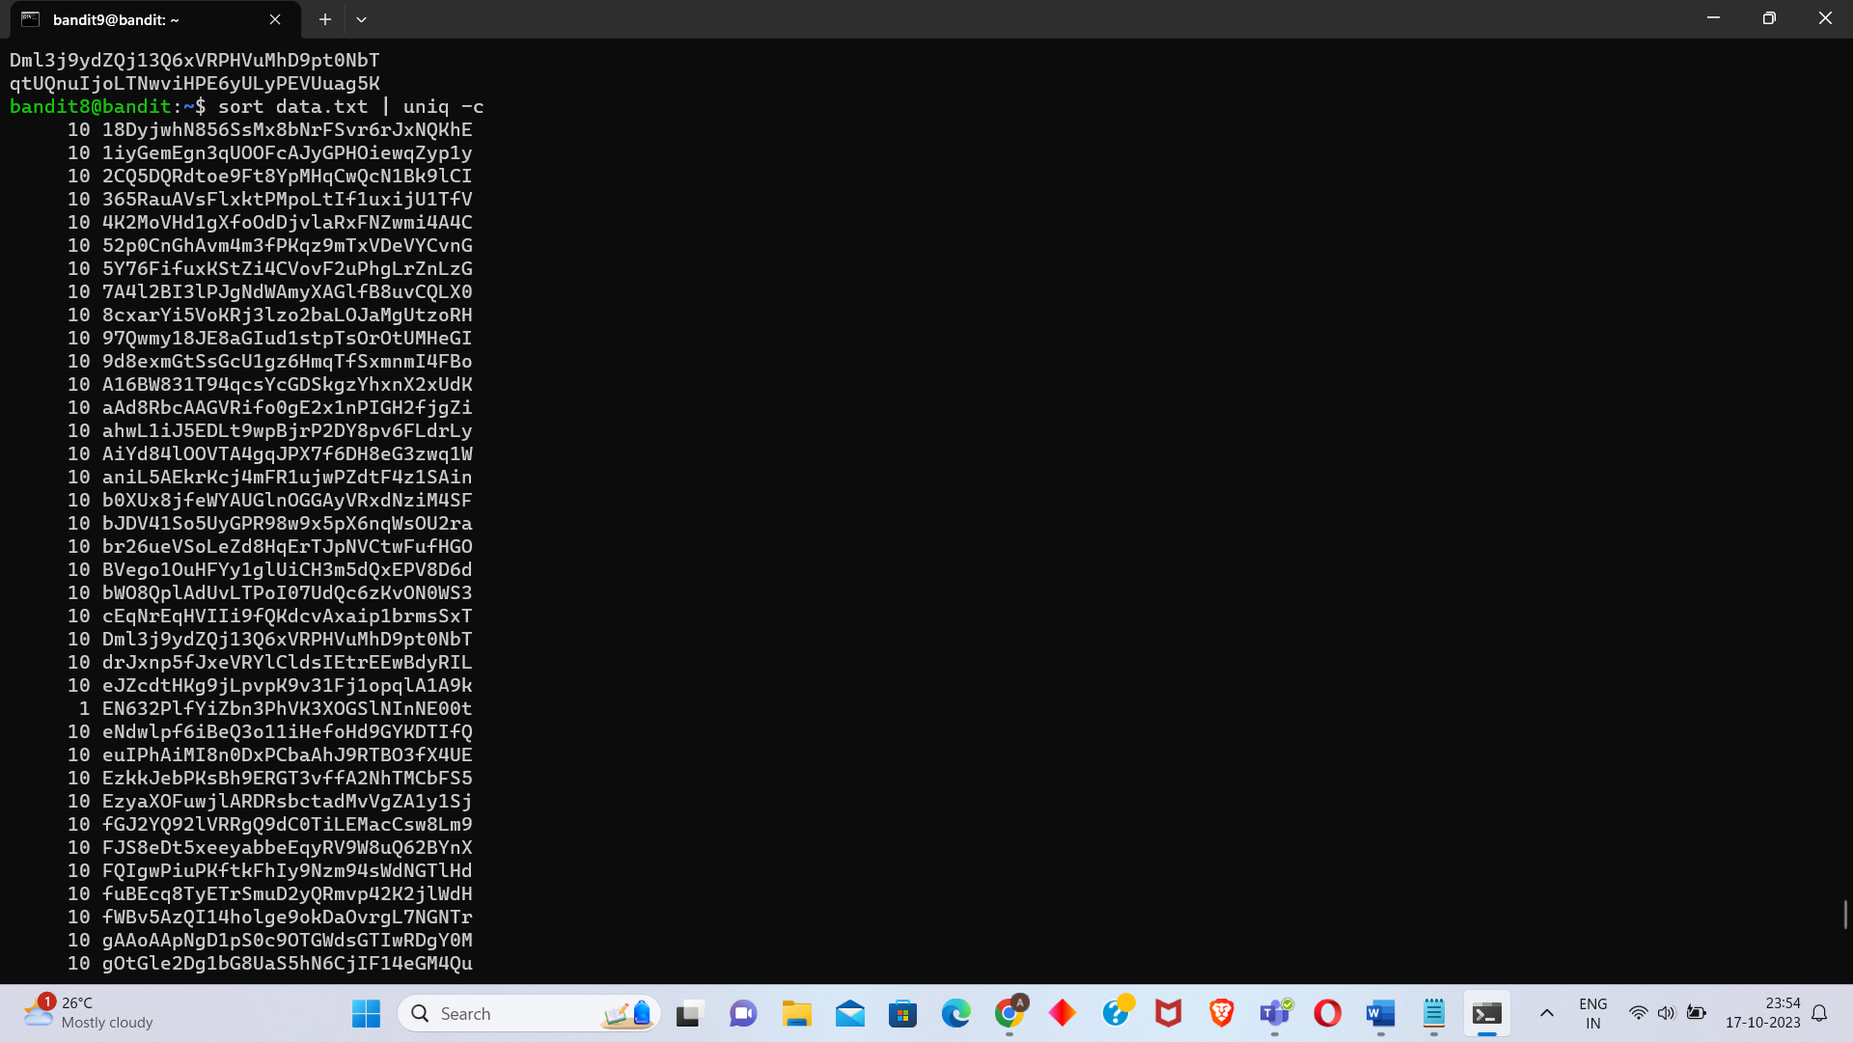 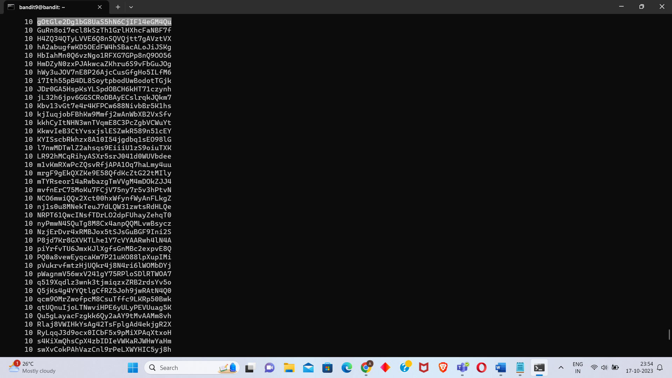 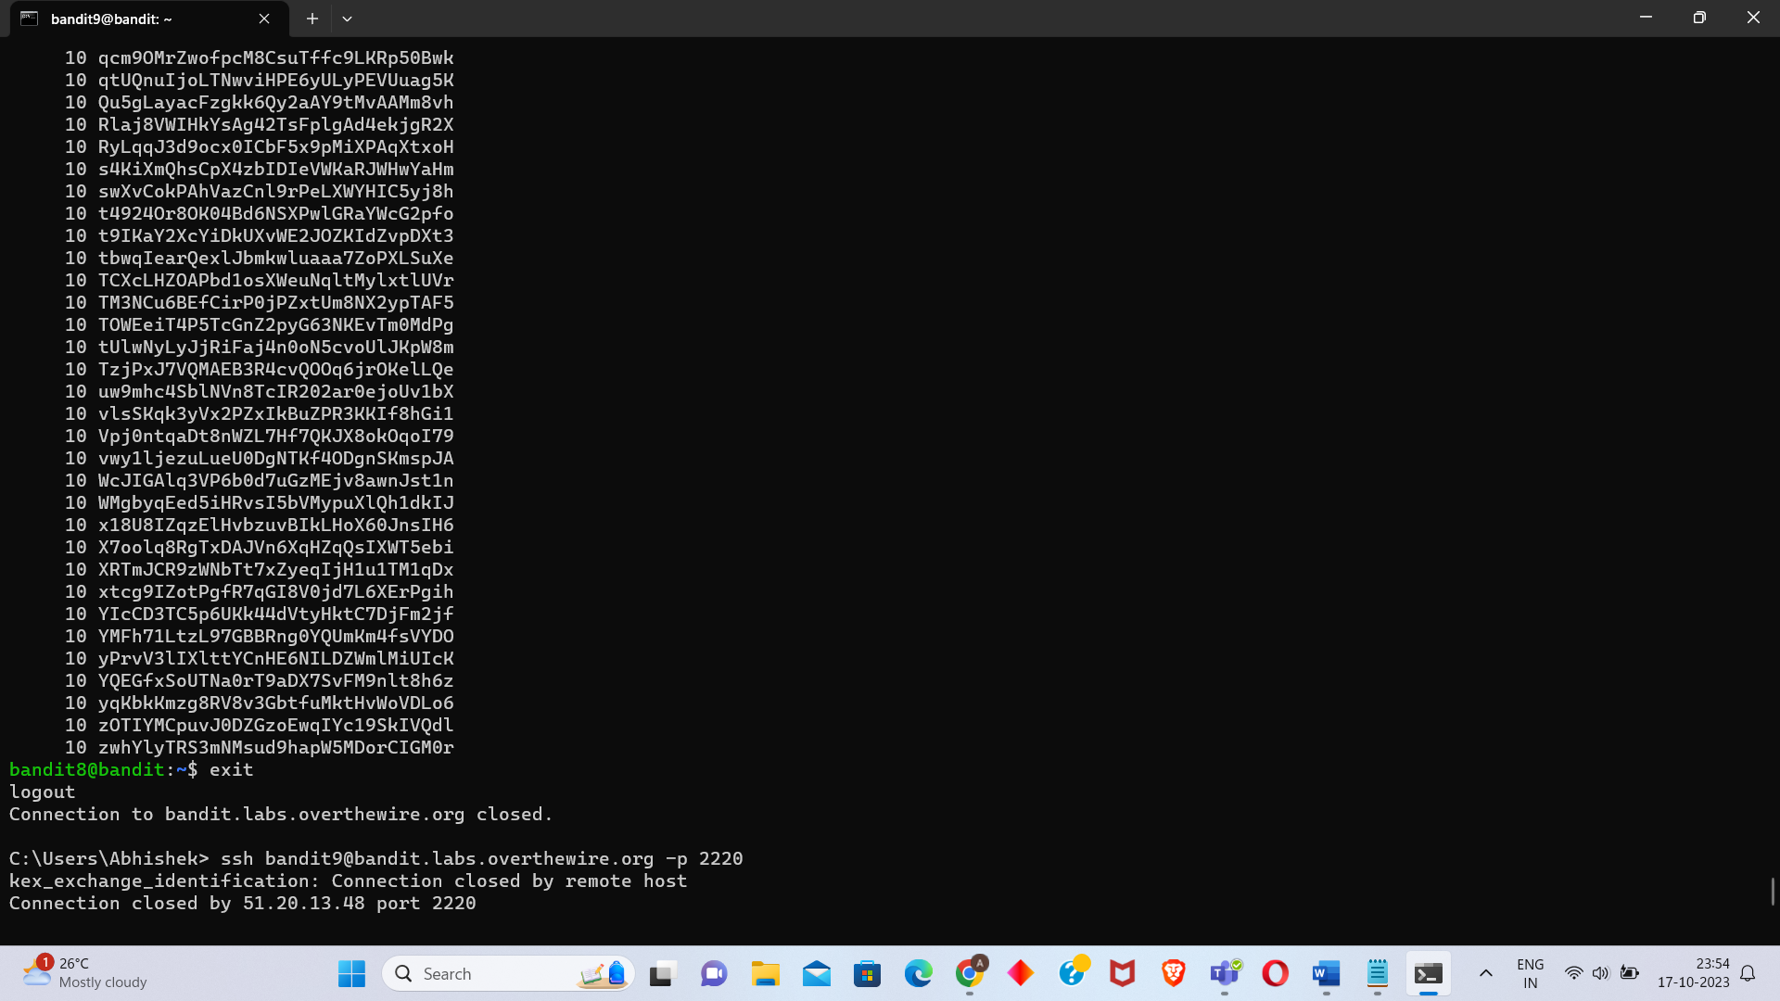

Level 09

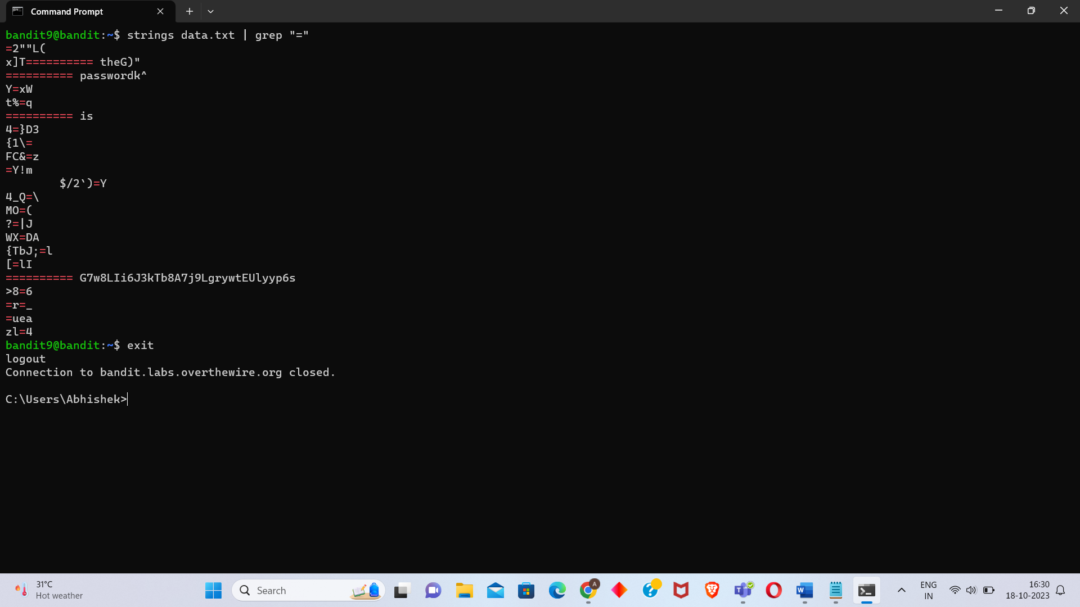

Level 10

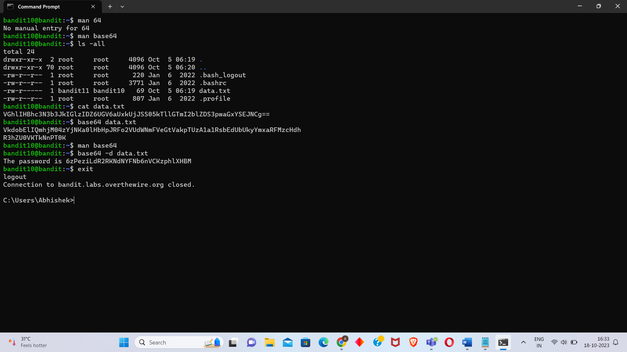

Level 11

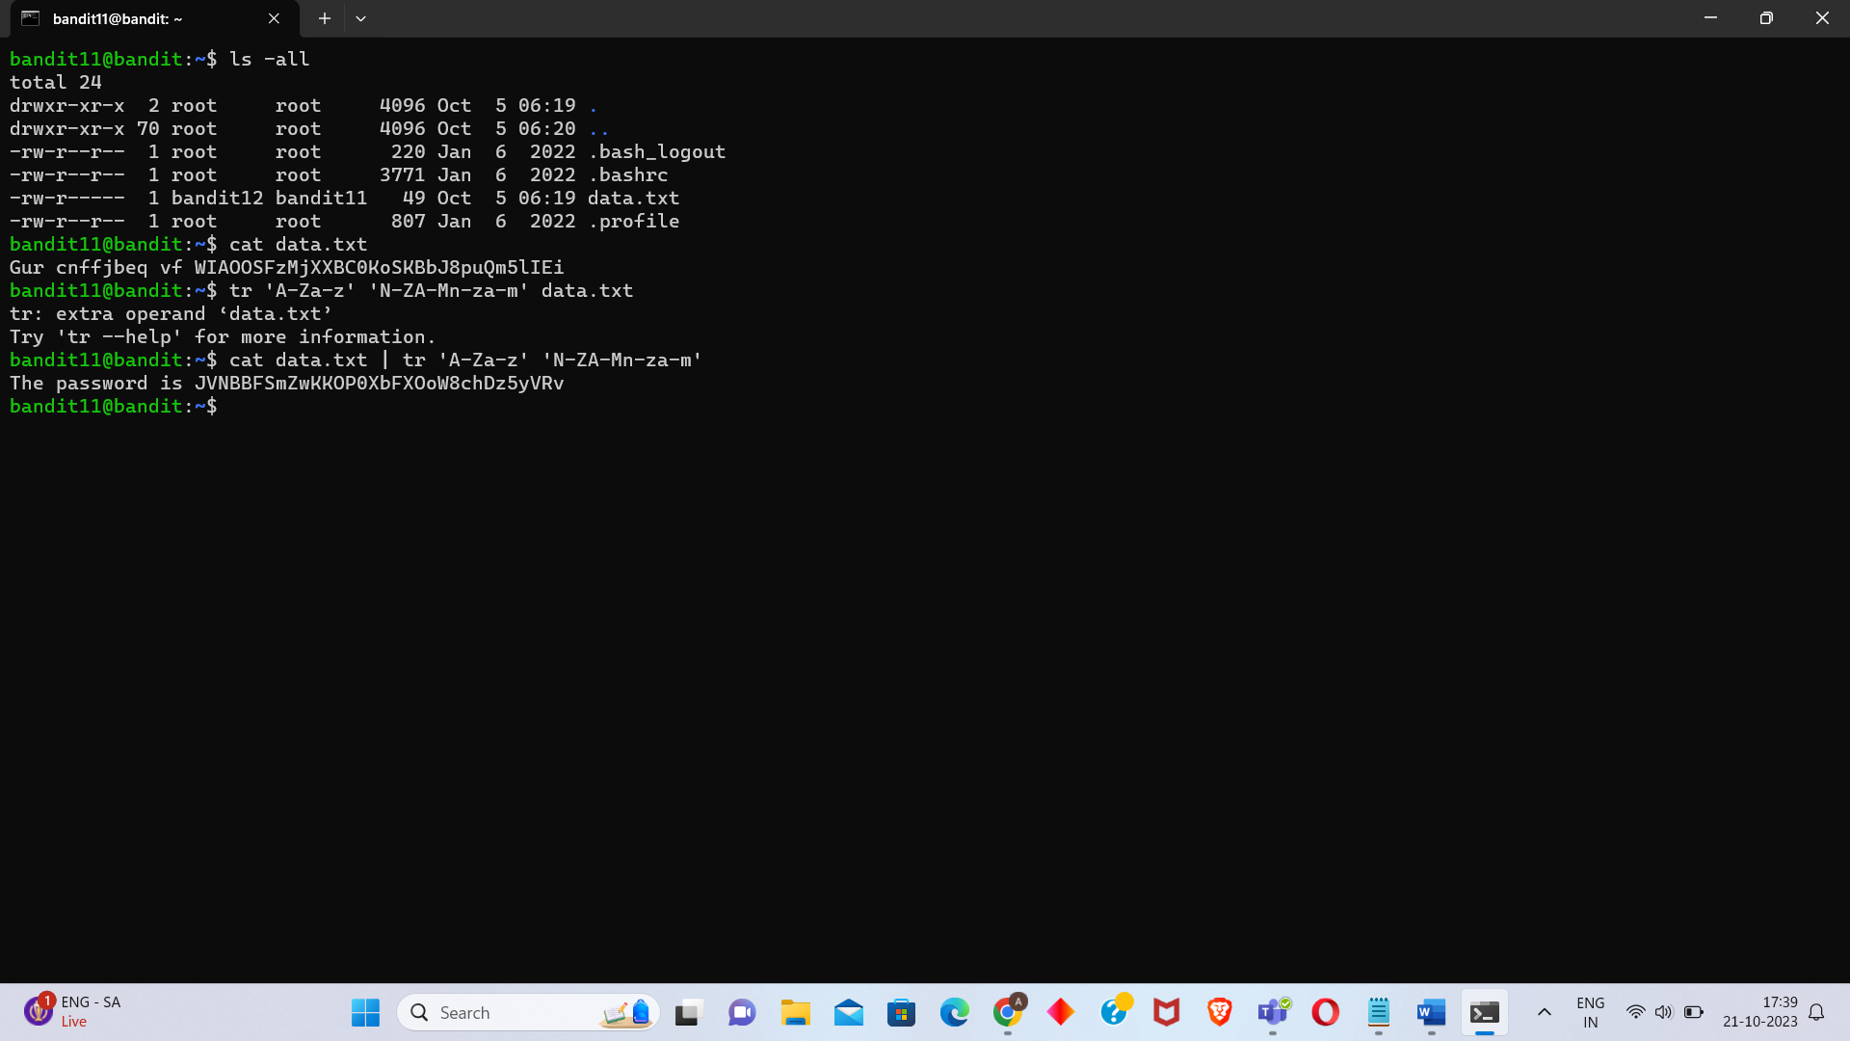

Level 12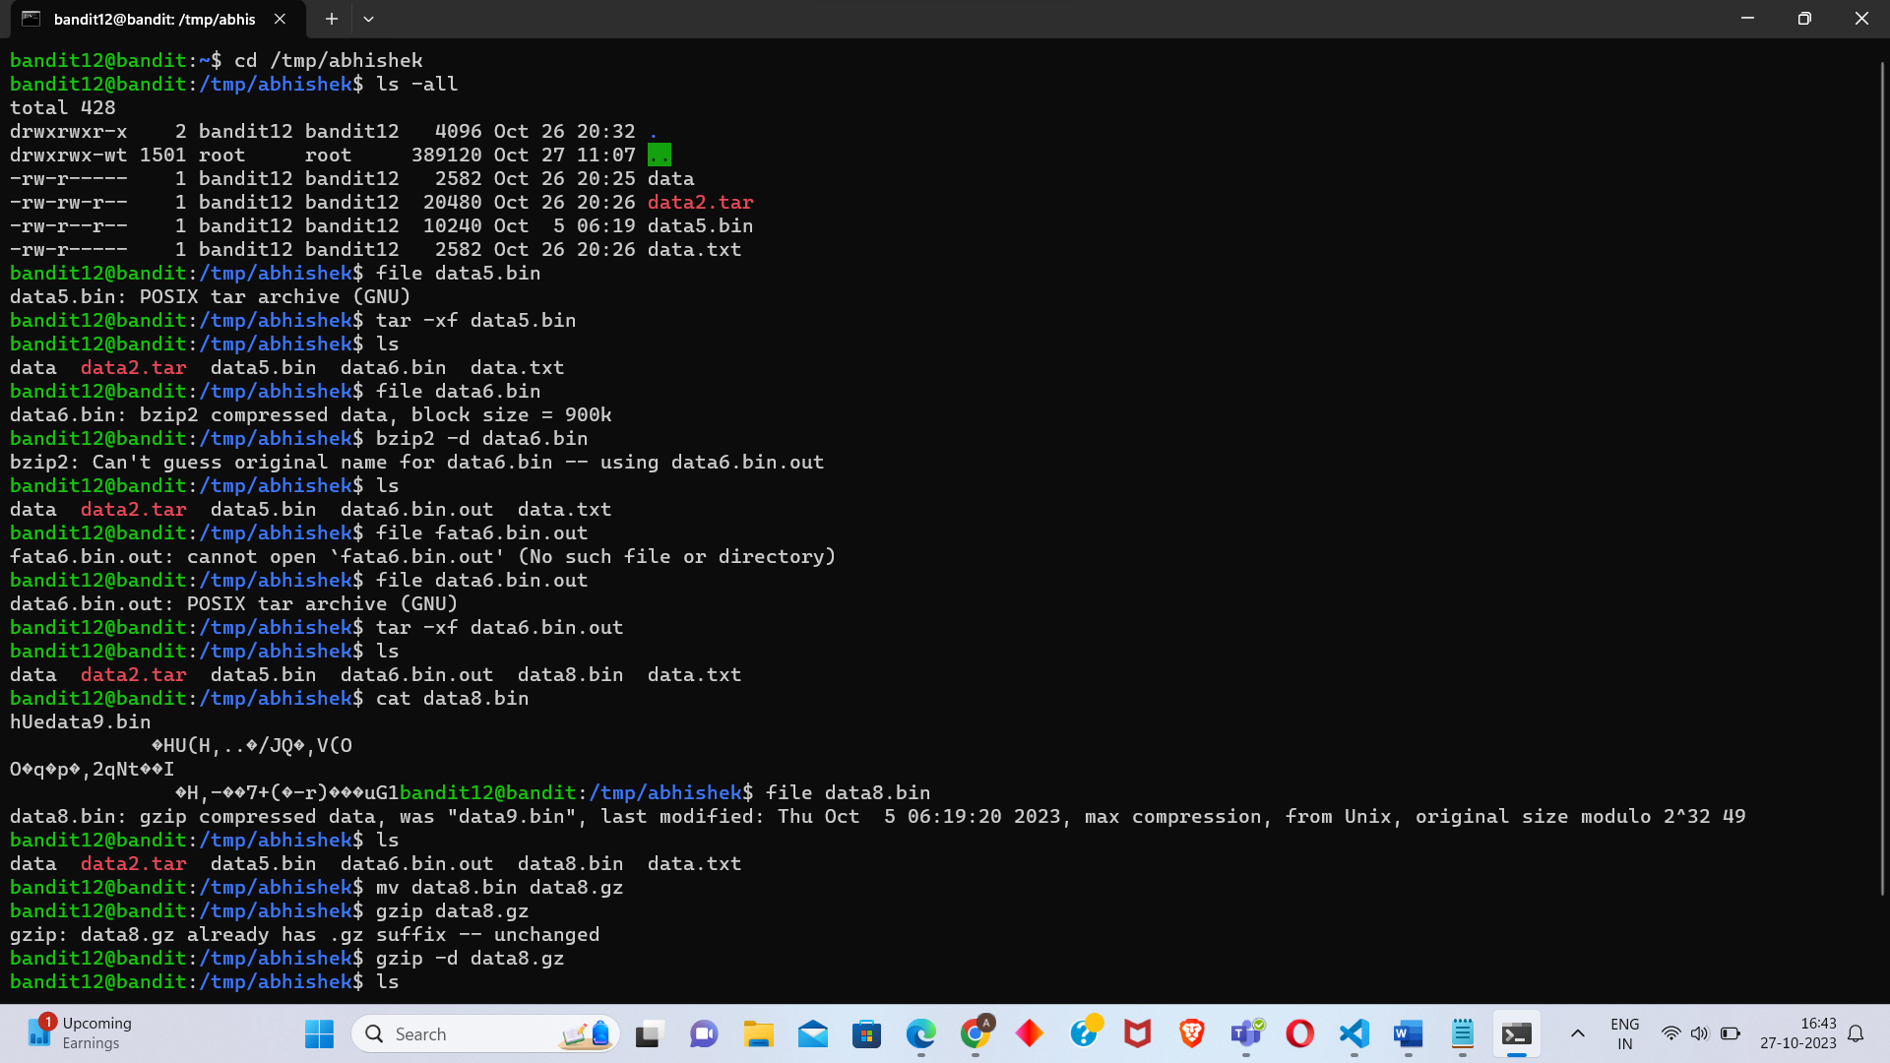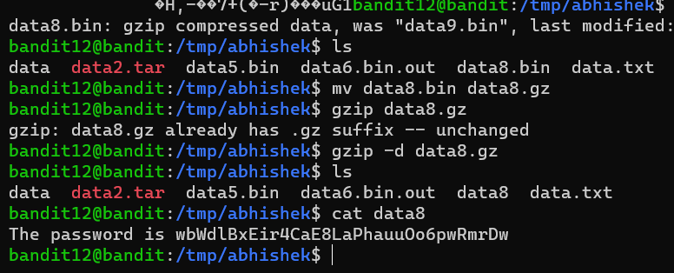

Level 13 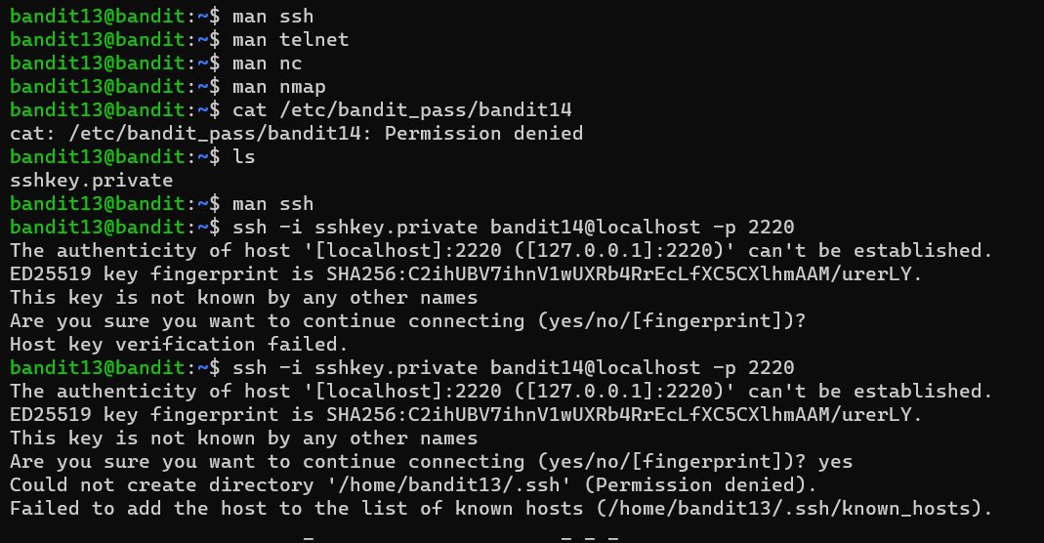 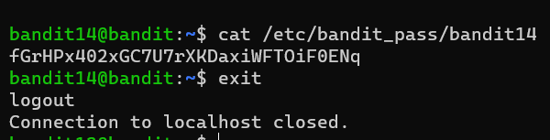

Level 14

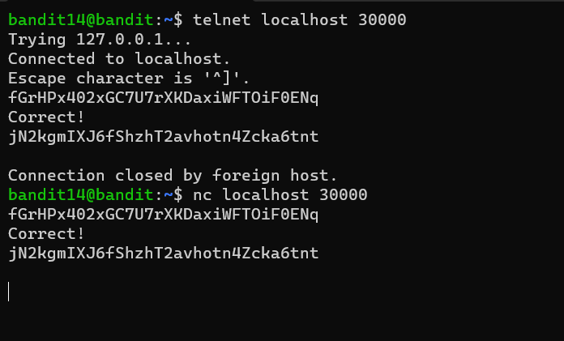

Level 15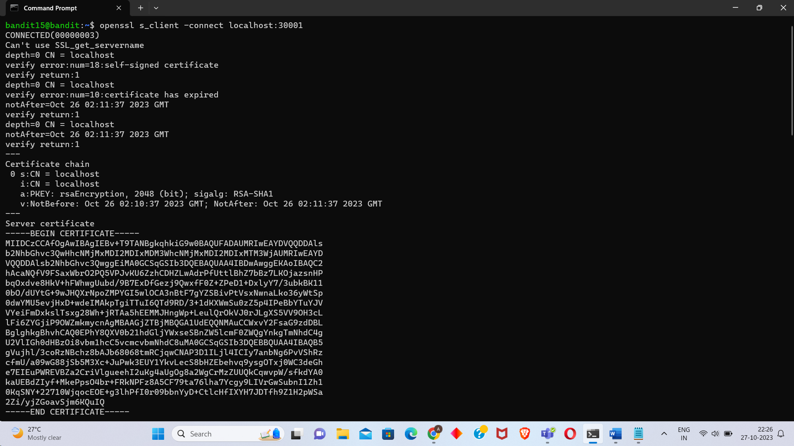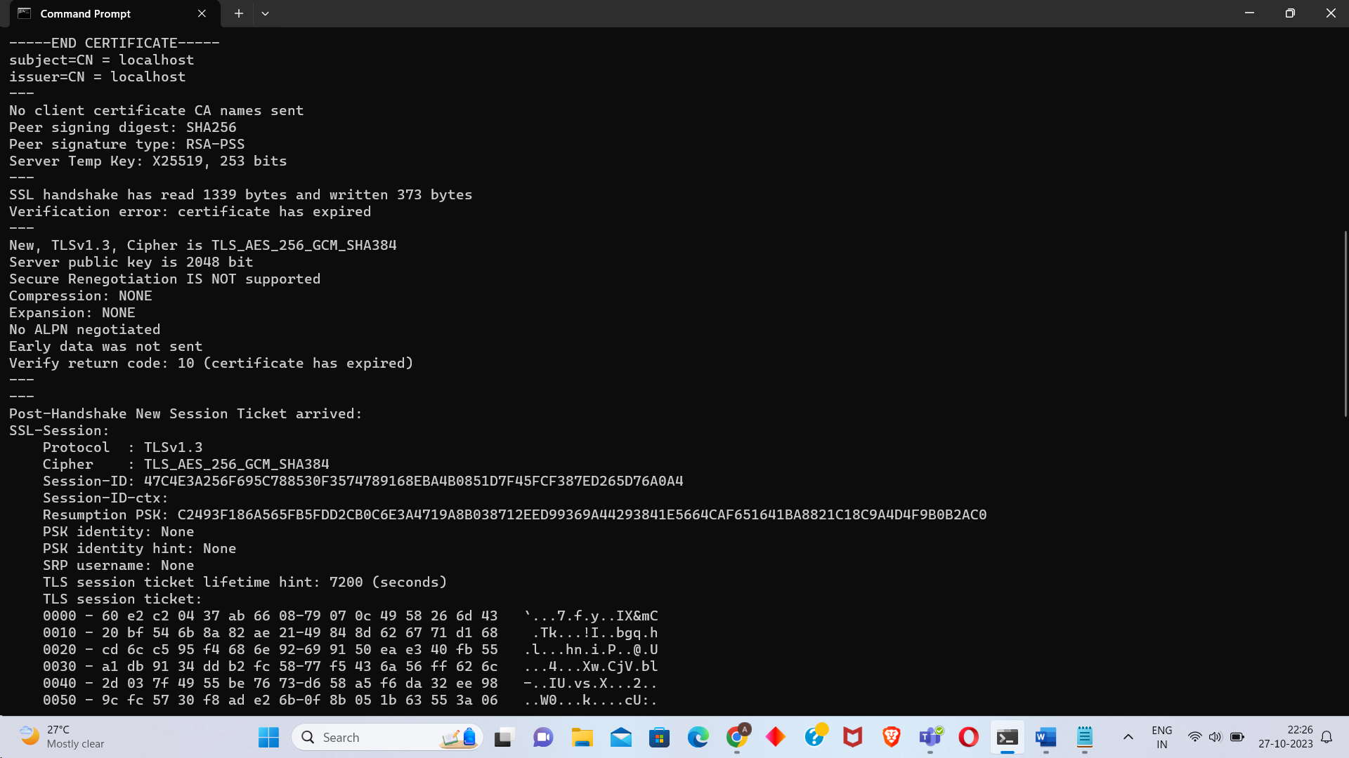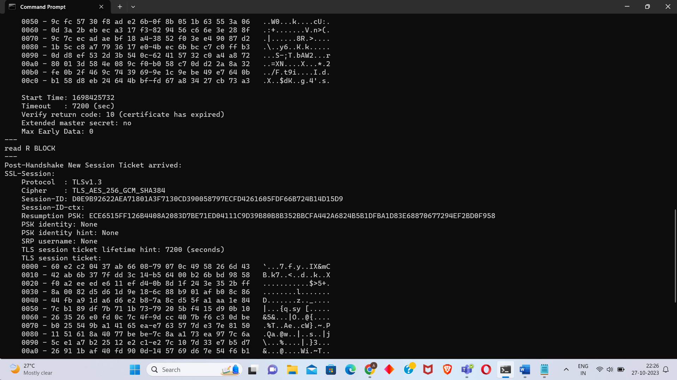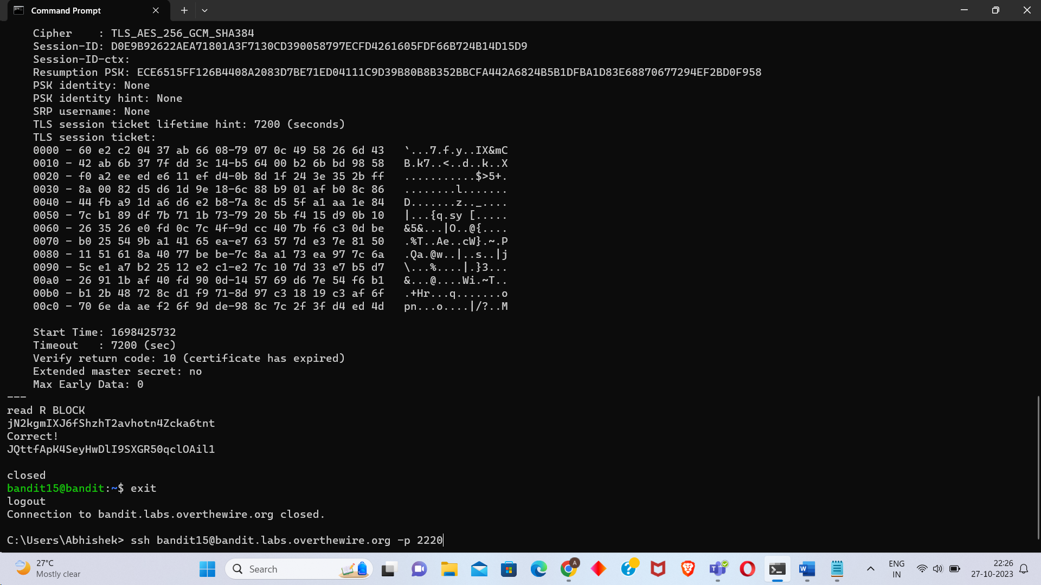

Level 16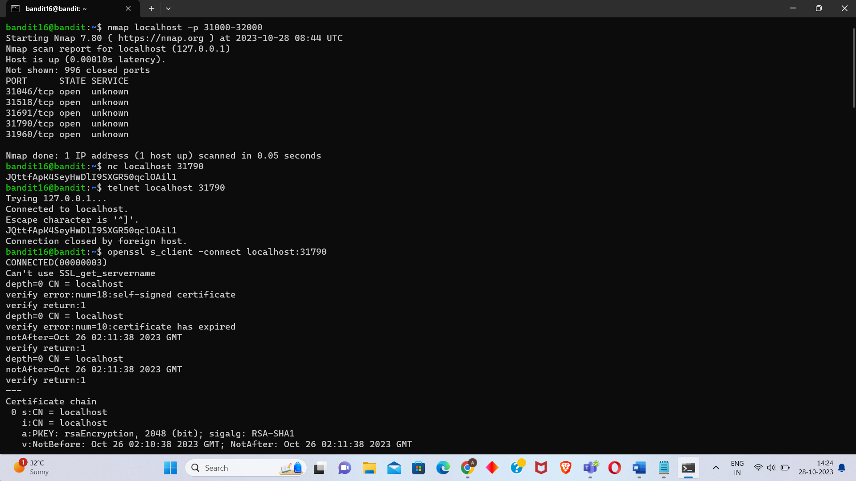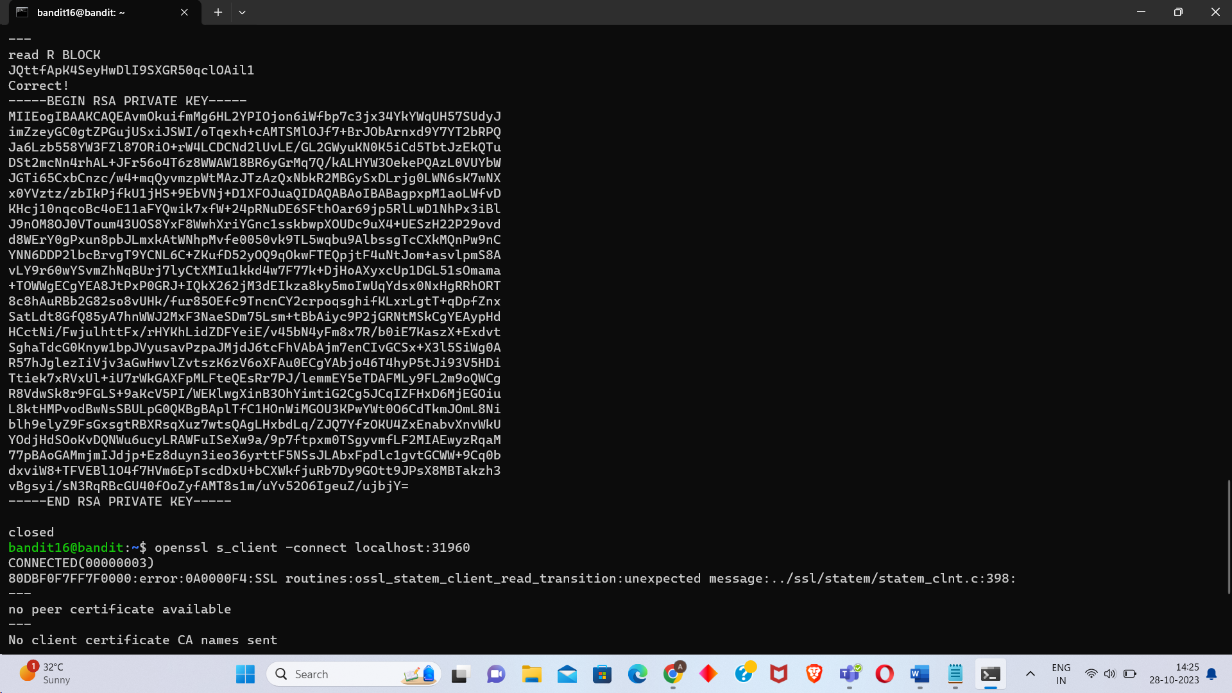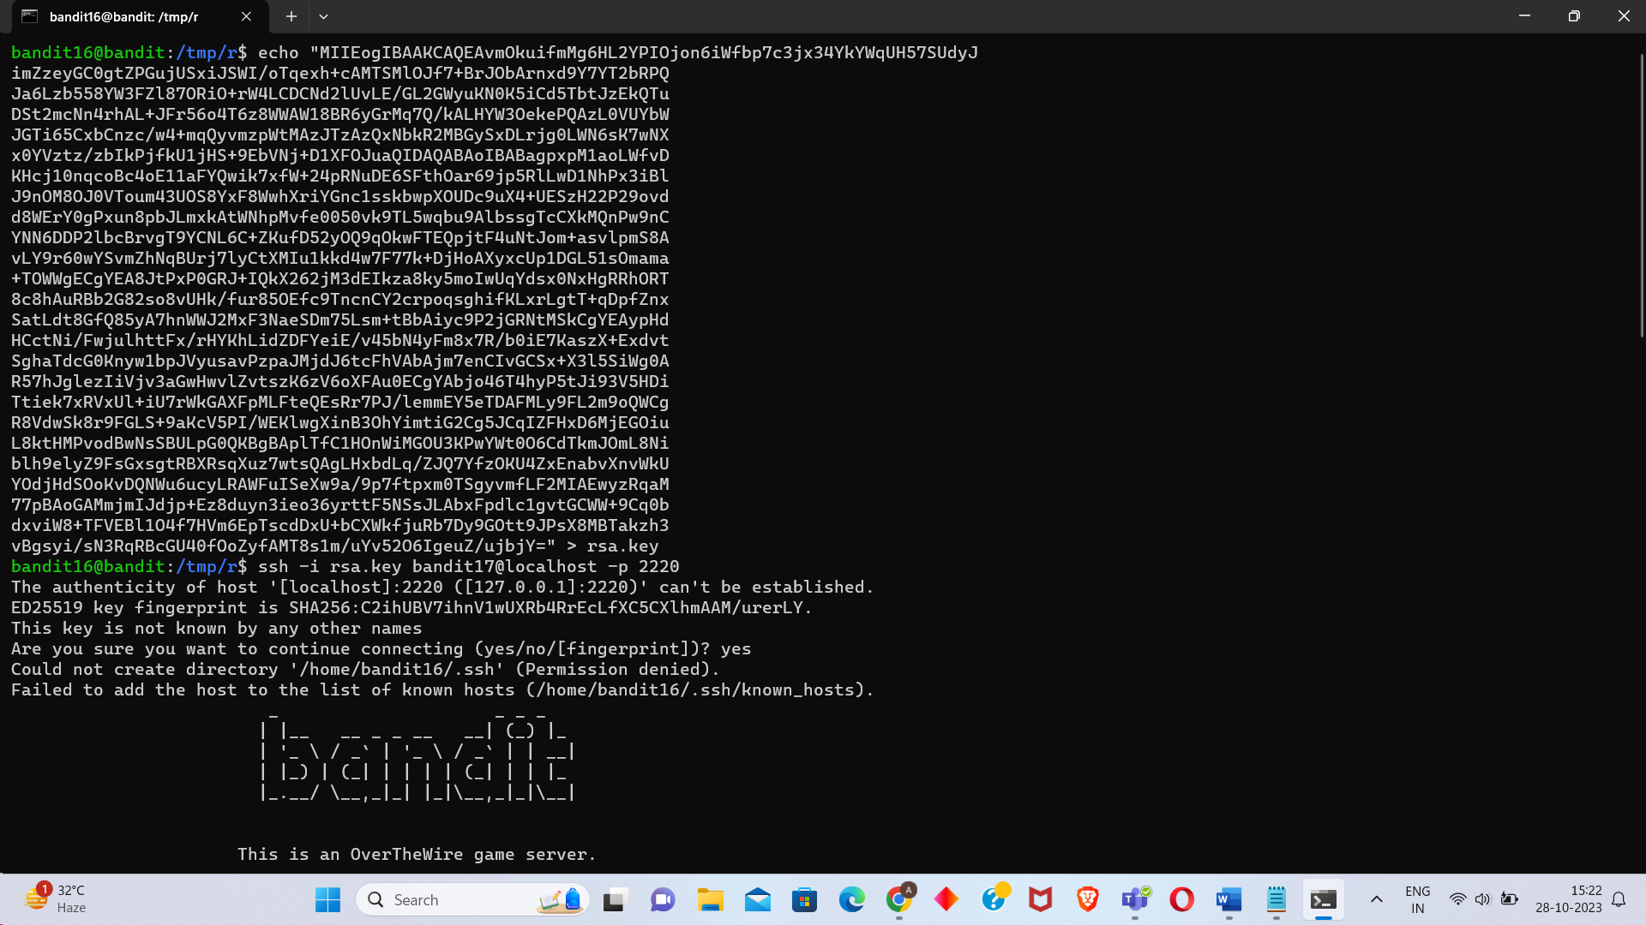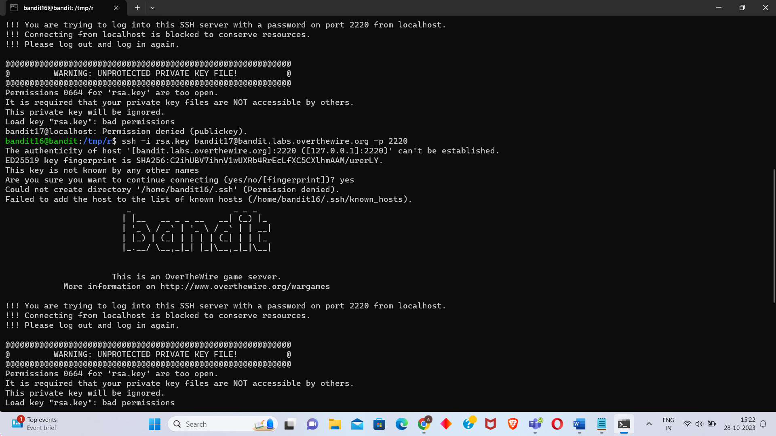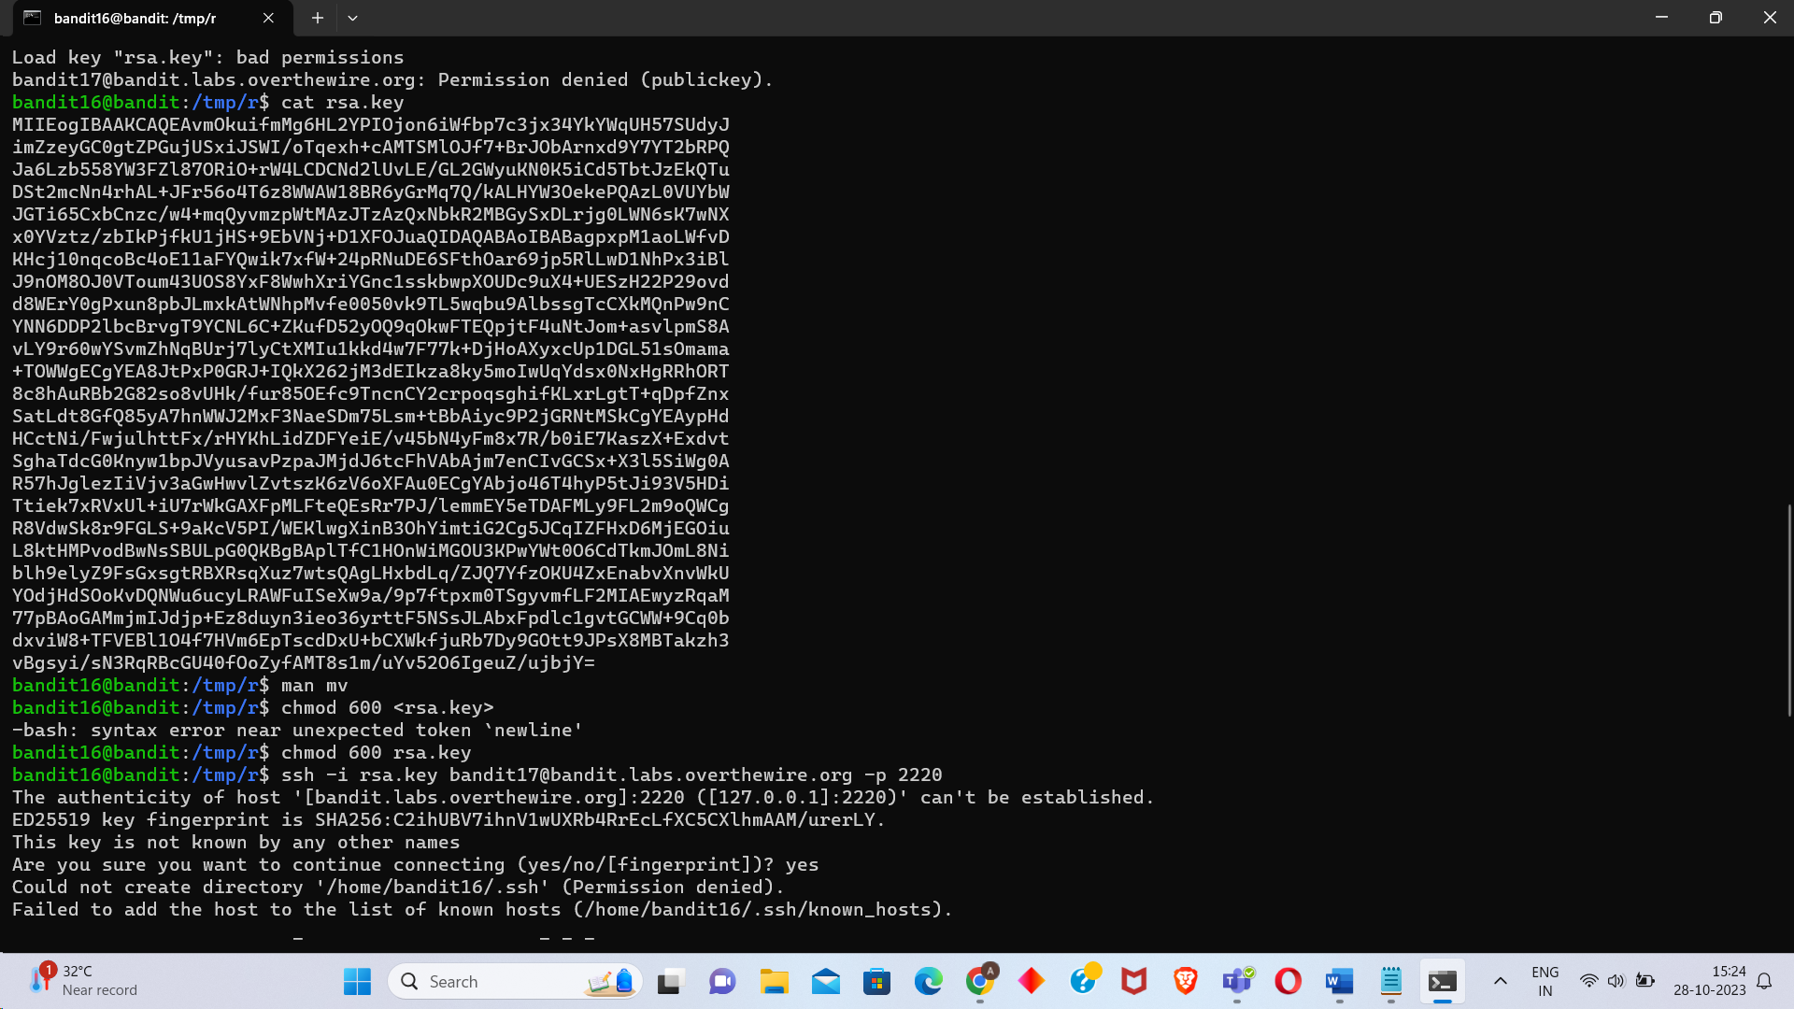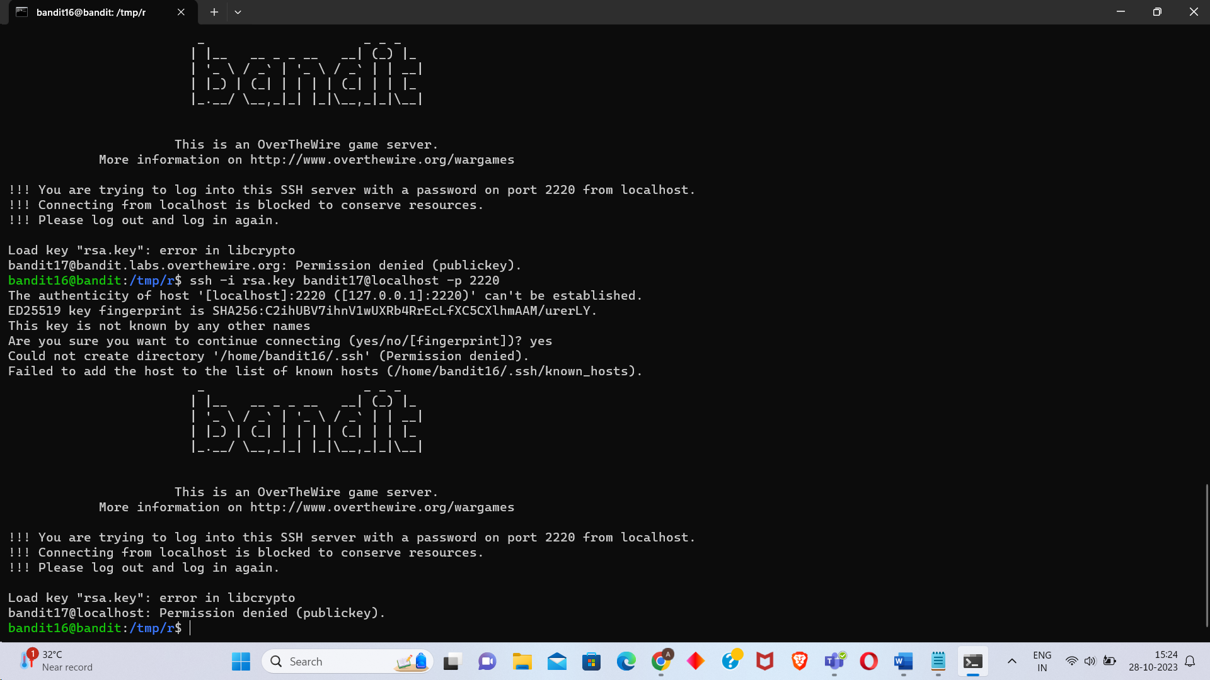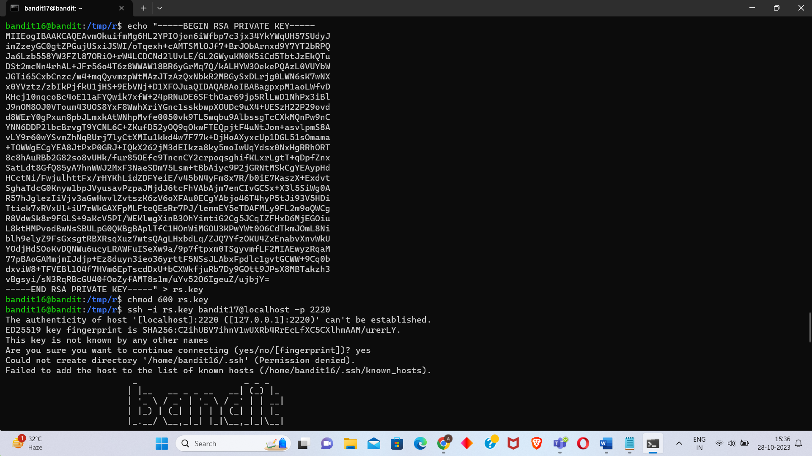 Level 17

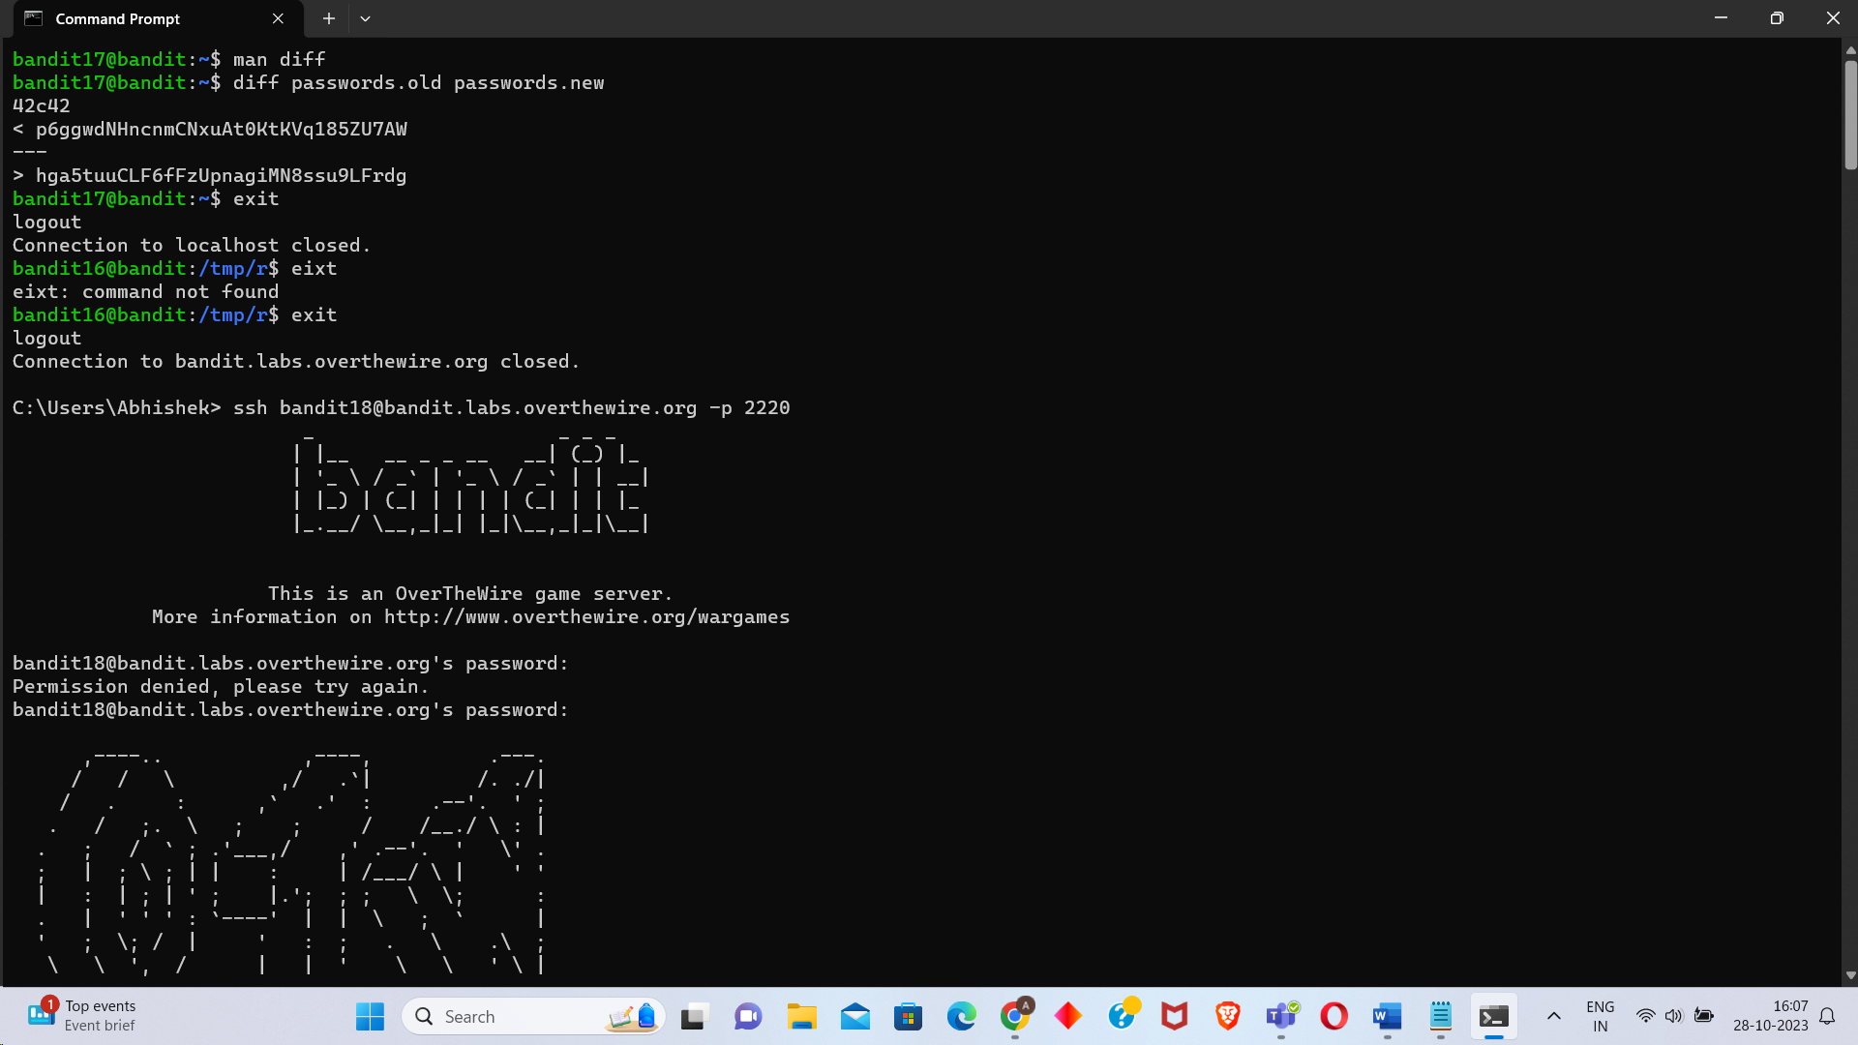 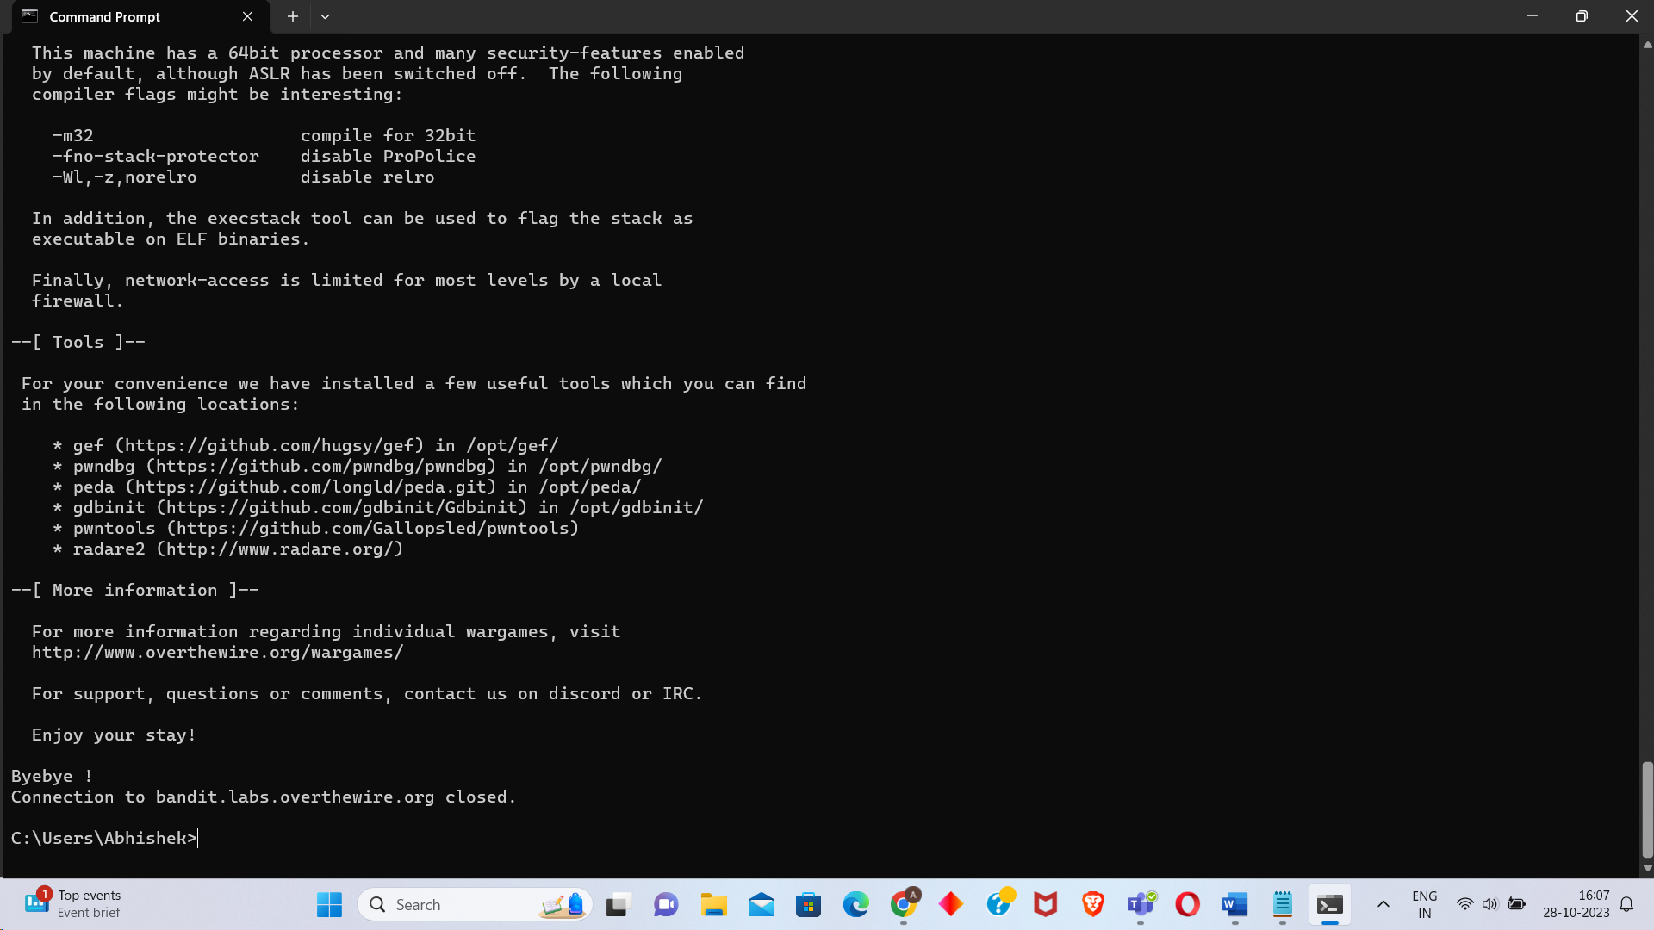 Level 18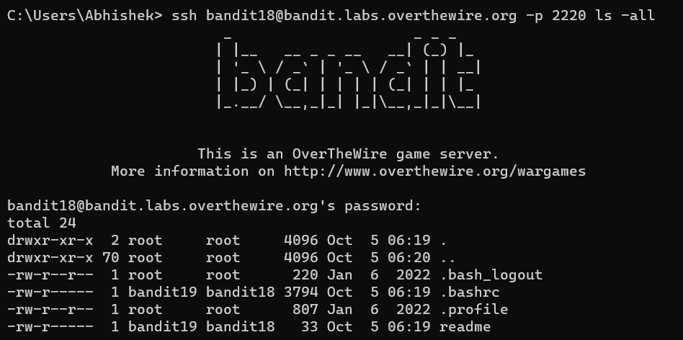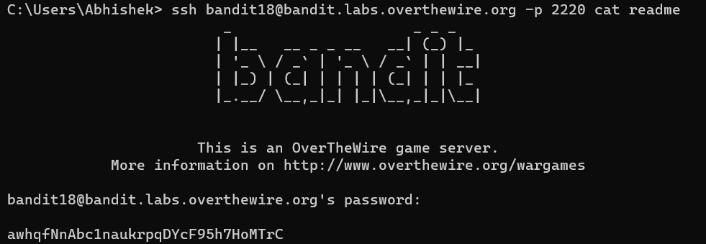

Level 19 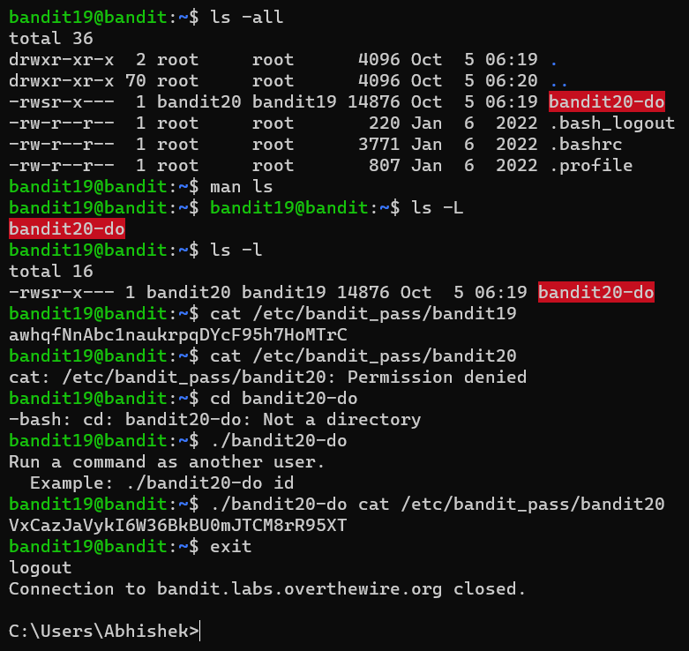 Level 20